Software Requirements Specification
AI Career Success Platform
Adama Science and Technology University (ASTU)
Version 2.0 — August 2026
Author: Feven Korso

Revision History
Version | Date | Author | Description
1.0 | July 2026 | Feven Korso | Initial Software Requirements Specification
2.0 | August 2026 | Feven Korso | Restructured and condensed for clarity; added system model diagrams (Chapter 6)

Table of Contents
Chapter 1 — Introduction
Chapter 2 — Overall Description
Chapter 3 — Functional Requirements
Chapter 4 — External Interface Requirements
Chapter 5 — Non-Functional Requirements
Chapter 6 — System Models
Chapter 7 — Assumptions, Constraints, and Business Rules
Chapter 8 — Appendices

Chapter 1 — Introduction

1.1 Purpose
Modern recruitment relies heavily on Applicant Tracking Systems (ATS) to filter resumes before a human ever sees them. Many capable candidates are screened out not for lack of qualification but because their resumes lack expected keywords, structure, or formatting. Job seekers also routinely struggle with writing effective resumes, tailoring cover letters, preparing for interviews, identifying missing skills, and managing multiple applications — typically across several disconnected tools.
The AI Career Success Platform is a single, intelligent web application that supports users across the entire job-search lifecycle. It combines Artificial Intelligence (AI), Natural Language Processing (NLP), and Retrieval-Augmented Generation (RAG) to analyze resumes, compare them against job descriptions, estimate ATS compatibility, recommend skill improvements, generate cover letters, prepare users for interviews, and track applications end to end.
This Software Requirements Specification (SRS) defines the functional and non-functional requirements of the system and serves as the primary reference for developers, testers, project supervisors, and future maintainers.

1.2 Background
A single job posting can attract hundreds or thousands of applications, making manual review impractical. ATS software automates the first pass but frequently rejects resumes for reasons unrelated to a candidate's actual fit — missing keywords, unconventional formatting, or incomplete sections. Job seekers additionally face difficulty writing professional resumes, understanding ATS expectations, identifying skill gaps, writing personalized cover letters, preparing for interviews, and organizing applications. Advances in AI now make it possible to provide intelligent, responsible guidance on all of these fronts without replacing human judgment.

1.3 Objectives
General objective: to develop an intelligent AI-powered career platform that helps job seekers optimize their resumes, improve employability, and manage the job application process from one place.
Specific objectives:
- Allow users to upload and automatically parse PDF resumes.
- Compare resumes with job descriptions and estimate ATS compatibility.
- Identify missing keywords and skills, and recommend improvements.
- Generate customized cover letters and interview preparation materials.
- Track job applications and provide personalized career guidance.
- Maintain a secure account system and retain analysis history for future reference.

1.4 Scope
The platform targets students, graduates, professionals, and job seekers. It comprises the following modules: User Management, Resume Management, Job Description Management, Resume Analysis, AI Recommendations, Cover Letter Generation, Interview Preparation, Career Guidance, Job Application Tracking, a Career Dashboard, and Administration.

1.5 Out of Scope (Version 1)
- Direct job posting by employers or automatic submission to external job boards
- Salary negotiation tools and payment processing
- Online video interviews and social networking features
- Recruitment agency, payroll, or employee management functionality
- Visa application processing

1.6 Intended Audience
- Students — to understand system requirements and scope
- Developers — to implement functionality per documented requirements
- Testers — to verify compliance with requirements
- Project supervisors — to evaluate completeness and correctness
- Future maintenance teams — to support updates and enhancements

1.7 Definitions, Acronyms, and Abbreviations
Term | Meaning
AI | Artificial Intelligence
ATS | Applicant Tracking System
API | Application Programming Interface
NLP | Natural Language Processing
LLM | Large Language Model
RAG | Retrieval-Augmented Generation
JWT | JSON Web Token
CRUD | Create, Read, Update, Delete
REST | Representational State Transfer
ORM | Object Relational Mapping
OCR | Optical Character Recognition
RBAC | Role-Based Access Control

1.8 Assumptions
- Users have internet access and basic computer literacy.
- Uploaded resumes are readable PDF documents.
- External AI services and the PostgreSQL server are available when requested.
- Users provide accurate personal information.

1.9 Constraints
- AI analysis depends on third-party AI service availability.
- PDF parsing accuracy depends on document quality.
- ATS score is an estimate, not a guarantee of recruiter decisions.
- Maximum upload size is 5 MB; Version 1 supports English-language resumes only.

1.10 References
- IEEE 29148 — Systems and Software Engineering: Requirements Engineering
- REST API Design Principles; React, Node.js, Express.js, PostgreSQL, Prisma ORM documentation
- OWASP Application Security Verification Standard (ASVS) and OWASP Top 10

Chapter 2 — Overall Description

2.1 Product Perspective
Unlike single-purpose resume checkers or ATS scanners, the AI Career Success Platform integrates resume analysis, job description comparison, interview preparation, career guidance, and application tracking into one system. It follows a three-tier architecture: a React presentation layer, a Node.js/Express business logic layer, and a PostgreSQL data layer, supplemented by external AI services and an optional vector database for retrieval-augmented recommendations.

2.2 Product Vision
The long-term vision is a comprehensive career development ecosystem that supports users from resume creation through job placement — helping close skill gaps, guiding continuous professional development, and reducing the time recruiters spend on poorly matched applications, while remaining scalable toward future recruiter and career-coach portals.

2.3 Product Goals
- Improve resume quality and resume-job matching accuracy
- Help users understand ATS requirements and close relevant skill gaps
- Generate professional cover letters and prepare users for interviews
- Organize job applications and deliver personalized career guidance responsibly

2.4 User Classes and Characteristics
Class | Access
Guest user | Not authenticated. May view public pages, register, and log in. Cannot upload resumes, access AI analysis, or track applications.
Registered user | Full access to resume, job description, AI analysis, cover letter, interview, tracking, and dashboard features.
Administrator | Full system access: manage users, review logs, monitor AI usage, configure platform settings.

2.5 Operating Environment
Client side: Windows, Ubuntu Linux, macOS, Android, and iOS on modern browsers (Chrome, Edge, Firefox, Safari). Server side: Ubuntu Server running Node.js LTS, Express.js, and PostgreSQL, optionally behind an Nginx reverse proxy.

2.6 Design Constraints
- Only PDF resumes supported in Version 1; default 5 MB upload limit
- Internet access required for all AI-powered features
- Passwords never stored in plain text; HTTPS required in production
- All uploaded files validated before processing

2.7 Key Business Rules
- A user must register before accessing protected features
- Each resume may be analyzed against multiple job descriptions, and vice versa
- AI-generated suggestions must not invent qualifications, experience, or certifications
- ATS scores are informational estimates and must never be represented as guarantees
- Job application records belong only to the authenticated user
- Deleted accounts have associated personal data removed or anonymized per the retention policy

Chapter 3 — Functional Requirements
This chapter summarizes the platform's 20 major features (SF-01 through SF-20). Each feature in the full engineering backlog additionally defines detailed preconditions, main/alternative/exception flows, database schema, and REST API endpoints; those specifications are maintained in the project's engineering documentation and are summarized here at the level needed for review and traceability.
ID | Feature | Primary actor | Priority | Description | Key business rule
SF-01 | User Registration | Guest | Critical | Create a secure account with email/password; passwords hashed with bcrypt; duplicate emails rejected. | Email must be unique. Password never stored in plain text. ToS acceptance required.
SF-02 | User Login | Registered User | Critical | Authenticate via email/password; issue JWT access and refresh tokens; track login history. | Only registered, verified, active accounts may log in. Failed logins are rate-limited.
SF-03 | Password Reset | Registered User | Critical | Time-limited, single-use reset tokens sent by email; all sessions revoked after reset. | Tokens expire in 30 minutes and are single-use. System never reveals whether an email exists.
SF-04 | Profile Management | Registered User | High | View and edit personal, professional, education, and social-link information; manage profile photo. | Only the profile owner may edit it. Email changes require re-verification.
SF-05 | Resume Upload | Registered User | Critical | Upload PDF resumes up to 5 MB; validate, store, and queue for parsing. | Only PDF supported in v1. Each resume belongs to exactly one user.
SF-06 | Resume Parsing | System (automatic) | Critical | Extract structured data (contact info, skills, experience, education, projects) from uploaded PDFs. | Original file is never modified. Duplicate skills are normalized and deduplicated.
SF-07 | Resume Management | Registered User | High | Organize, rename, archive, duplicate, download, and delete resumes; maintain version history. | Resume titles are unique per user. Deletion requires confirmation.
SF-08 | Job Description Upload & Parsing | Registered User | Critical | Paste or upload a job posting; extract required/preferred skills, experience, and education requirements. | Skills are normalized to a standard vocabulary before matching.
SF-09 | Resume–Job Matching | Registered User | Critical | Compare parsed resume against parsed job description across skills, experience, education, and keywords. | Scores are weighted estimates and do not guarantee hiring outcomes.
SF-10 | ATS Compatibility Estimation | Registered User | Critical | Estimate ATS-readiness based on structure, keyword coverage, and formatting. | Score is a platform estimate, not the output of any commercial ATS.
SF-11 | Skill Gap Analysis | Registered User | Critical | Identify missing qualifications, prioritize by impact, and generate a personalized learning roadmap. | Every gap is assigned a priority level (High / Medium / Low).
SF-12 | AI Resume Improvement | Registered User | Critical | Suggest rewrites for summary, experience, and skills sections; user approves changes individually. | AI never fabricates qualifications, employers, or achievements.
SF-13 | AI Cover Letter Generator | Registered User | High | Generate a tailored draft cover letter from resume, profile, and job description data. | Only verified profile/resume data is used; drafts remain fully editable.
SF-14 | AI Interview Preparation | Registered User | High | Generate technical, behavioral, situational, and resume-based interview questions with guidance. | Company-specific questions only generated when sufficient company data exists.
SF-15 | AI Mock Interview | Registered User | High | Simulate an interview with text/voice responses; AI evaluates and scores each answer. | Scores are for practice only and are not represented as hiring predictions.
SF-16 | Job Application Tracker | Registered User | High | Track applications through a status workflow with reminders, notes, and statistics. | Each application belongs to one user; status changes are timestamped.
SF-17 | Career Dashboard & Analytics | Registered User | High | Aggregate resume, ATS, skill-gap, interview, and application data into a personalized dashboard. | Analytics only include the authenticated user's own data.
SF-18 | Administration & User Management | Administrator | Critical | Search, suspend, reactivate users; manage roles; view platform and AI usage statistics. | Only Administrators access these functions; every action is audit-logged.
SF-19 | Notification & Reminder Management | Registered User | High | Deliver in-app and email notifications for application, interview, and account events. | Security notifications cannot be disabled by the user.
SF-20 | System Administration & Configuration | Administrator | Critical | Configure AI, email, security, and storage settings; monitor system health and background jobs. | Critical changes require confirmation and are recorded in configuration history.

Feature IDs map directly to functional requirement ranges FR-001 through FR-200 in the engineering backlog, and to the use cases shown in the Use Case Diagram (Figure 6.2) and the Requirements Traceability Matrix (Appendix 8.6).

Chapter 4 — External Interface Requirements

4.1 User Interface
The platform is a responsive web application supporting desktop, tablet, and mobile. Every page includes a header (logo, search, notifications, profile menu), a navigation sidebar (Dashboard, Resumes, Job Descriptions, Matching, ATS Reports, Skill Gap, Cover Letters, Interview Prep, Mock Interviews, Applications, Analytics, Settings — with User Management, System Administration, and Audit Logs added for Administrators), a main content area, and a footer.

4.2 Hardware Interfaces
The system is cloud-based and requires no specialized hardware. Minimum client: dual-core CPU, 4 GB RAM, modern browser. Minimum server: 4 CPU cores, 8 GB RAM, SSD storage, Linux; recommended production: 8 CPU cores, 16–32 GB RAM, load balancer, and backup server.

4.3 Software Interfaces
Layer | Technology | Purpose
Frontend | React, TypeScript, Tailwind CSS, React Query, Chart.js | User interface, dashboards, forms, charts
Backend | Node.js, Express.js | Business logic, authentication, AI integration, file processing
Database | PostgreSQL | Persistent storage for users, resumes, reports, analytics
Authentication | JWT, refresh tokens, bcrypt | Secure login and session management
AI integration | External AI service (provider-agnostic layer) | Resume improvement, cover letters, interview evaluation
Resume parsing | pdf-parse, Mammoth | Extract text from uploaded PDF/DOCX resumes
Storage | Local storage (dev) or cloud object storage (prod) | Resume files, cover letters, reports

4.4 Communication Interfaces
All communication uses HTTPS with a REST API and JSON payloads, authenticated via an Authorization: Bearer <JWT_TOKEN> header. File uploads use multipart/form-data. Standard HTTP status codes (200, 201, 400, 401, 403, 404, 409, 422, 429, 500) are used consistently across endpoints.

4.5 Accessibility and Internationalization
The interface aims to conform to WCAG 2.1 Level AA where practical: keyboard navigation, alternative text, adequate color contrast, and screen-reader compatibility. Version 1 supports English only, but user-facing text is separated from application logic to support future localization.

Chapter 5 — Non-Functional Requirements
Quality attributes that apply across the platform, independent of any single feature.
Category | Requirement
Performance | Login ≤ 2s; dashboard ≤ 3s; resume parsing ≤ 10s; AI resume/cover-letter generation ≤ 20s.
Scalability | Support 5,000+ registered users and 500+ concurrent users; horizontal scaling of application servers.
Availability | Target 99.5% monthly uptime, excluding scheduled maintenance.
Reliability | Validate all inputs; retry failed background jobs; recover gracefully without data corruption.
Security | bcrypt/Argon2 password hashing; JWT sessions; RBAC; HTTPS everywhere; validated file uploads.
Usability | Consistent navigation; clear validation messages; responsive across desktop, tablet, and mobile.
Accessibility | Aim for WCAG 2.1 Level AA: keyboard navigation, accessible labels, sufficient color contrast.
Maintainability | Modular architecture; separated business/presentation logic; externalized configuration.
Portability | Support modern browsers; containerized (Docker) deployment; cloud-provider agnostic.
AI quality | AI output stays editable and is never presented as fact; no fabricated qualifications.
Compliance | Comply with applicable data-protection law; support account/data deletion requests.

AI-specific note: AI-generated content is always presented as assistance and remains editable by the user; the system does not knowingly fabricate qualifications, experience, or certifications, and informs the user (falling back to non-AI functionality where possible) if an AI service is unavailable.

Chapter 6 — System Models
This chapter presents the platform's structural and behavioral models: how users and external systems interact with the platform (context and use case diagrams), how data is structured (the entity relationship diagram), and how the system behaves over time (activity and state diagrams).

6.1 Context Diagram
The platform sits at the center of its operating environment, exchanging data with two human actor types and three external services. Users submit resumes, job descriptions, and application data and receive back reports, generated documents, and notifications. Administrators configure the system and receive usage and audit data. The AI, email, and cloud storage services are consumed as external dependencies.
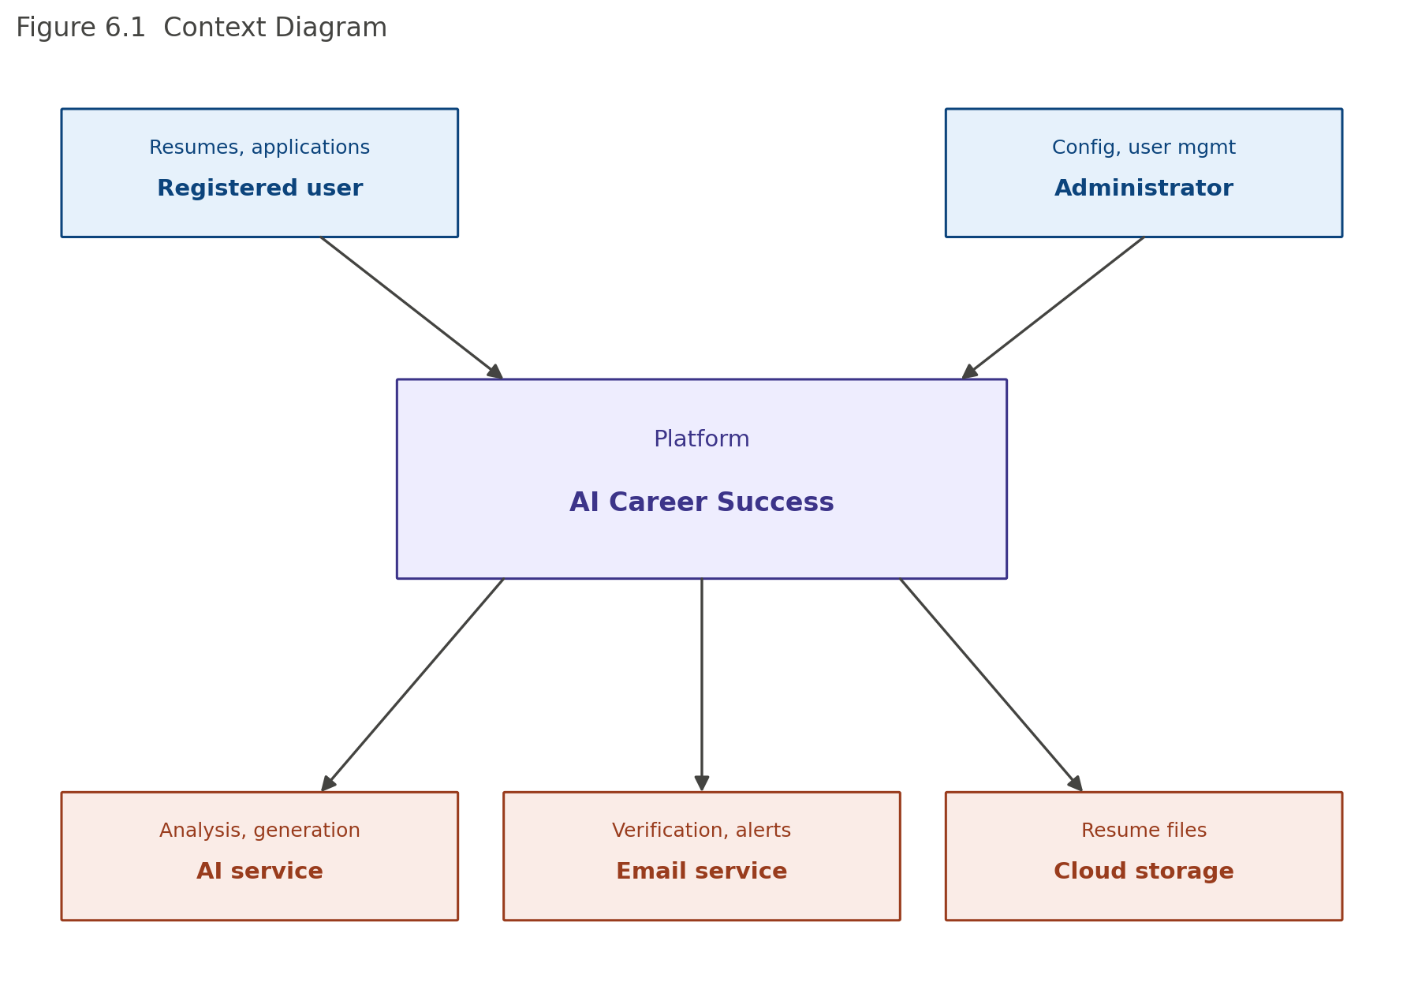
Figure 6.1 — Context diagram showing the platform's external actors and service dependencies.

6.2 Use Case Diagram
Registered users interact with six major use-case groups covering the full resume-to-offer journey; Administrators interact with four platform-management use cases. This mirrors the feature groupings in Chapter 3.
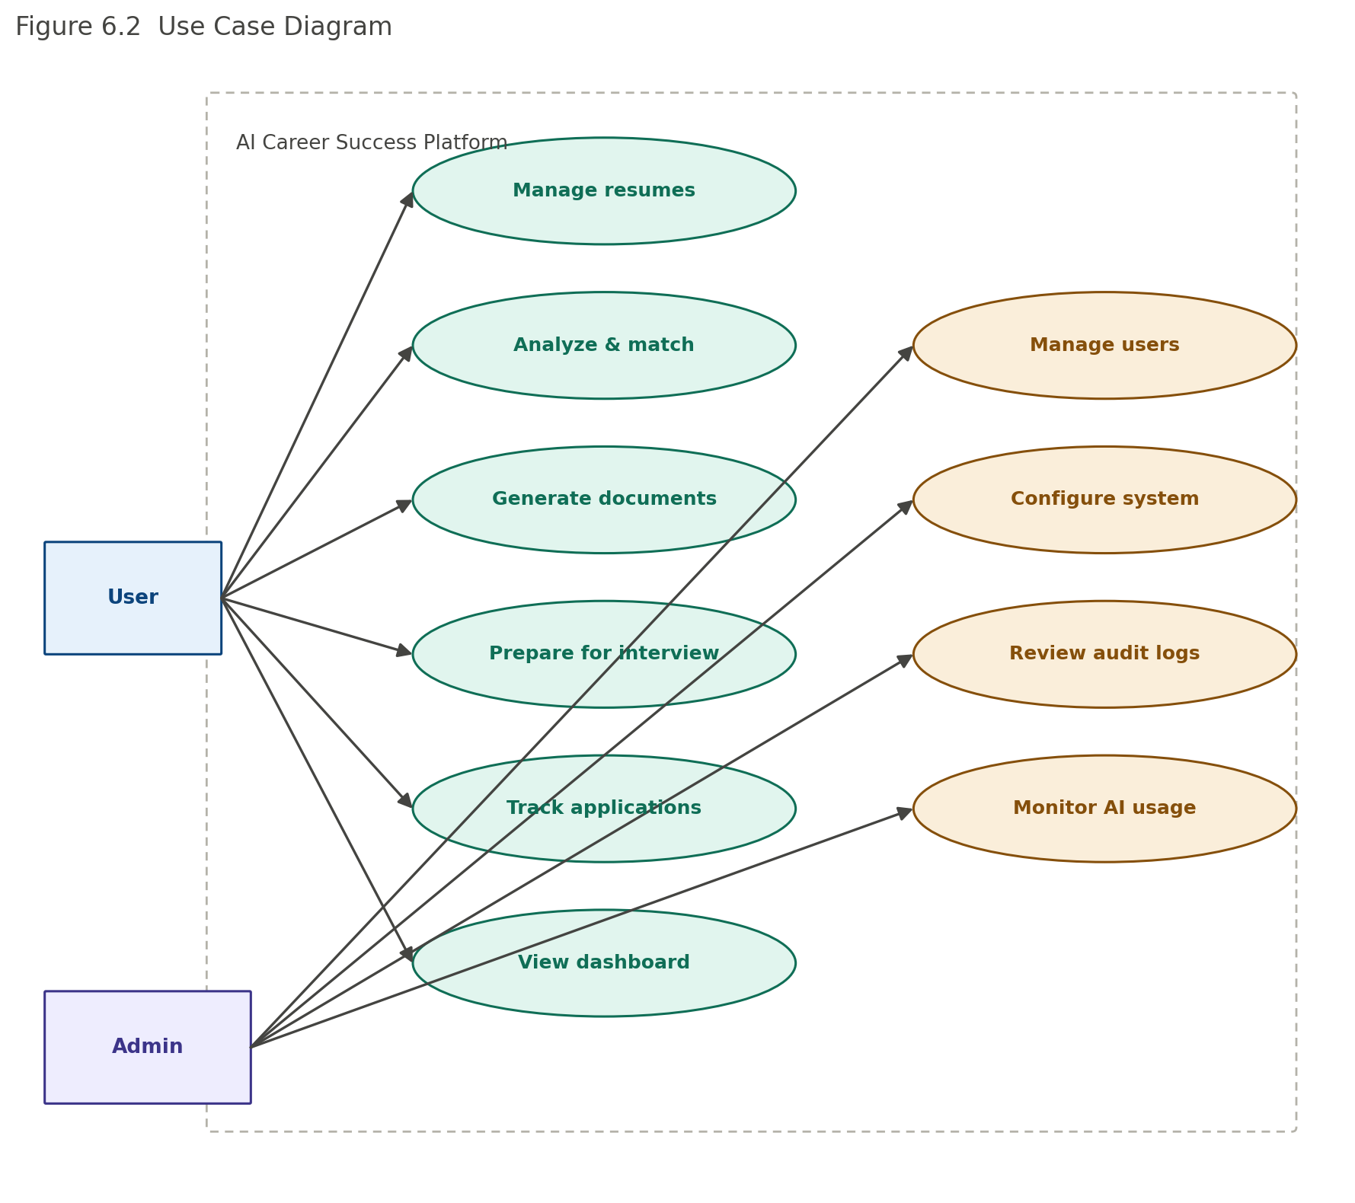
Figure 6.2 — Use case diagram grouping platform functionality by actor.

6.3 Entity Relationship Diagram
The core data model centers on the user, who owns resumes, job descriptions, and job applications. A resume and a job description combine to produce a match analysis, which in turn drives an ATS report and a skill gap report. Resumes also feed cover letter generation and mock interview sessions.
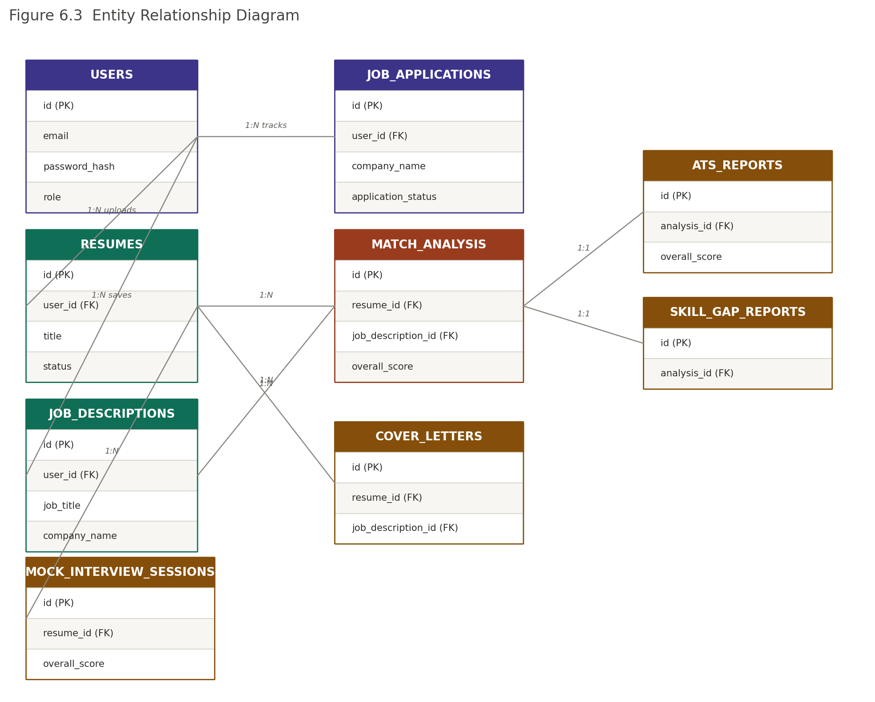
Figure 6.3 — Entity relationship diagram of the core platform schema.

6.4 Activity Diagram — Resume Analysis
The most common end-to-end user journey: after logging in, a user uploads a resume (automatically parsed), uploads or pastes a target job description, and triggers analysis. The system produces a match score, an ATS compatibility estimate, and a skill gap report, then presents all three on a single results view.
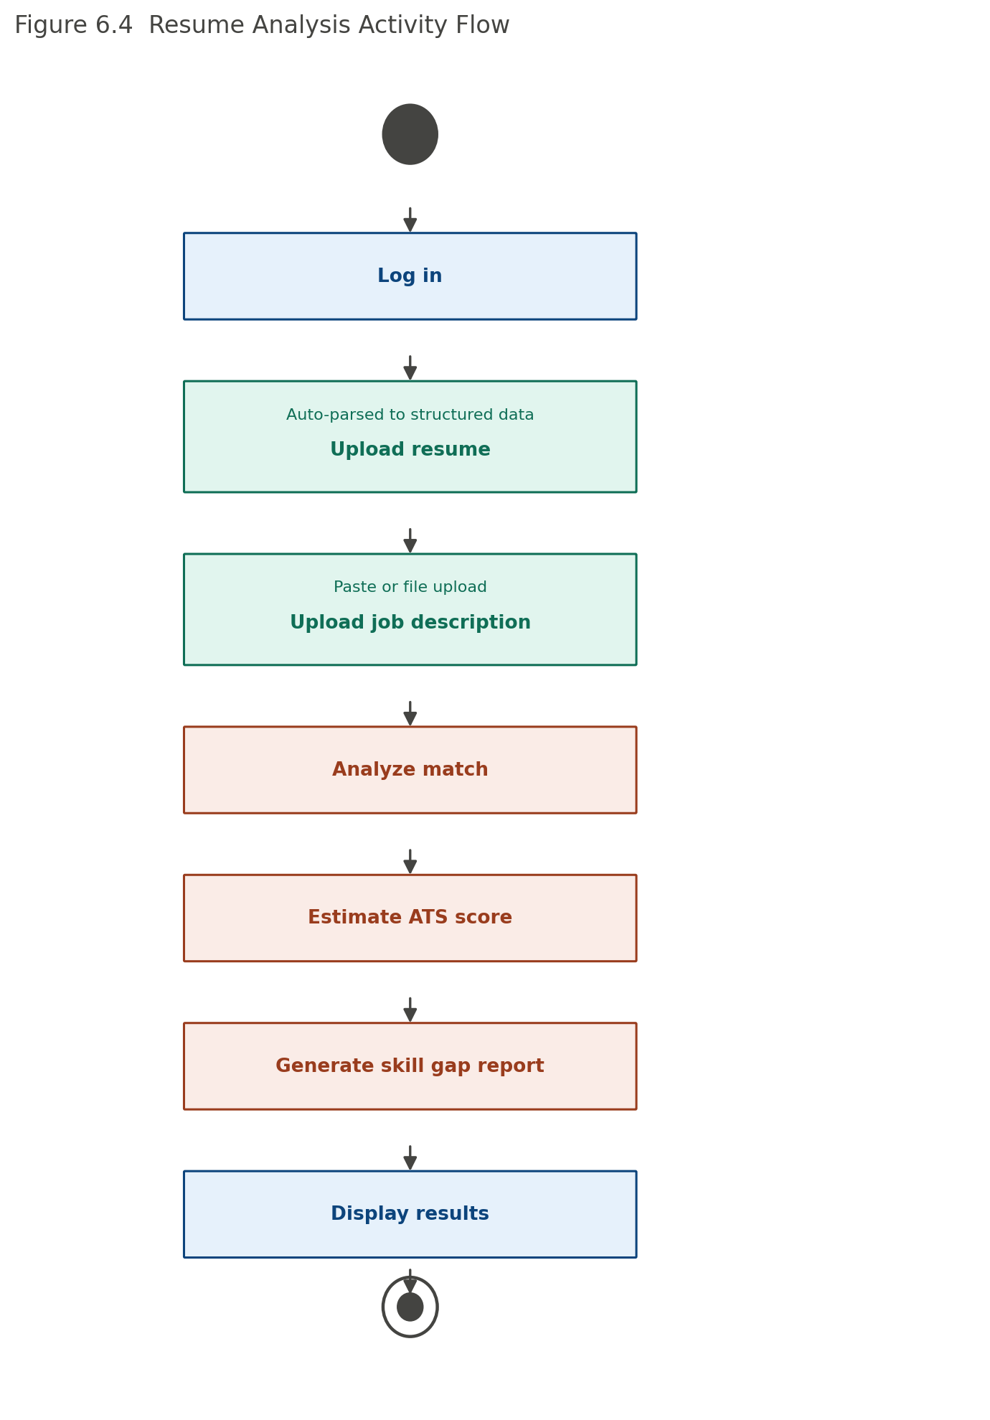
Figure 6.4 — Activity flow for the primary resume analysis journey.

6.5 State Diagrams
Two entities carry meaningful lifecycle state. A resume moves from Uploaded through Parsing, Parsed, and Analyzed states before optionally being Archived. A job application moves through a linear pipeline from Draft to Offer, branching to Accepted or Declined — and, from any active stage, may also move to Rejected or Withdrawn (omitted from the diagram for clarity).
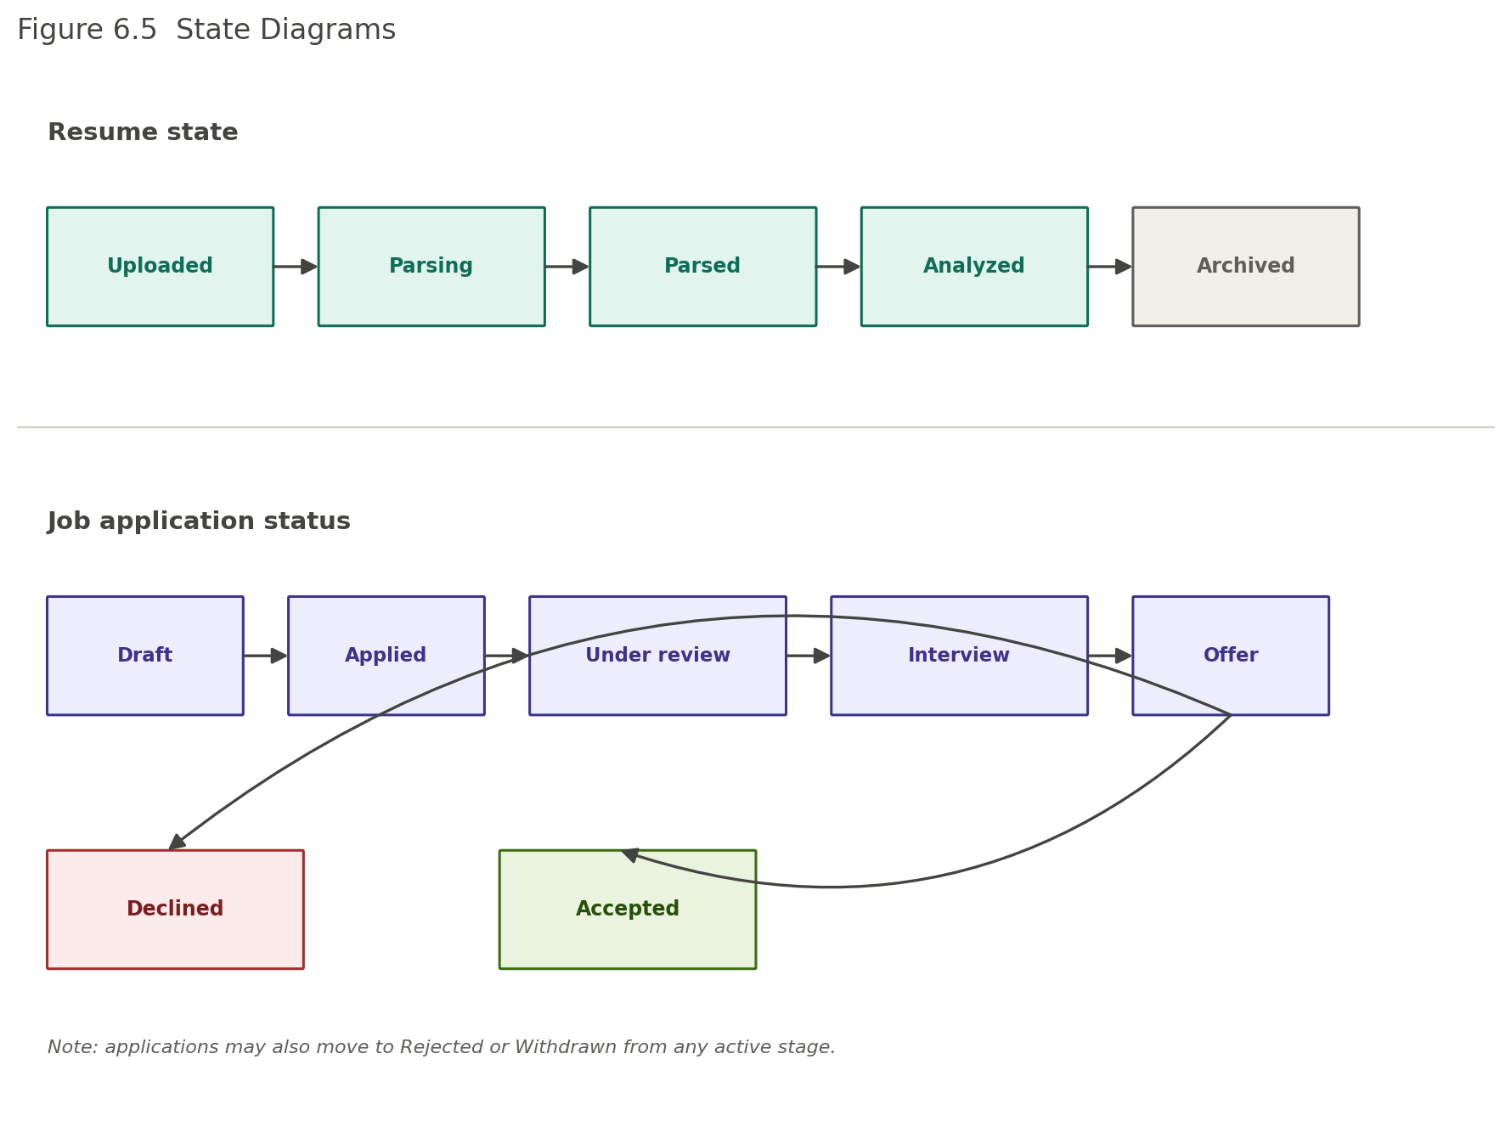
Figure 6.5 — State diagrams for resume processing and job application status.

6.6 Data Dictionary (Core Entities)
Entity | Key fields
User | id (UUID, PK), email (unique), password_hash, role
Resume | id (PK), user_id (FK), title, status, version
Job Description | id (PK), user_id (FK), job_title, company_name
Match Analysis | id (PK), resume_id (FK), job_description_id (FK), overall_score
ATS Report | id (PK), analysis_id (FK), overall_score, missing_keywords
Job Application | id (PK), user_id (FK), company_name, application_status

Chapter 7 — Assumptions, Constraints, and Business Rules

7.1 Assumptions
- Users have stable internet access and can use a modern web browser.
- Uploaded resumes and job descriptions contain enough information for meaningful analysis.
- External AI and email services are generally available and respond within expected time limits.
- Users review AI-generated output before using it in real job applications.

7.2 Technical Constraints
- Frontend: React, TypeScript, Tailwind CSS. Backend: Node.js, Express.js. Database: PostgreSQL.
- Authentication uses JWT with secure password hashing; all traffic is REST over HTTPS.
- The AI integration layer should support swapping providers without major architectural changes.

7.3 Legal and Security Considerations
- The platform respects applicable data-protection law in its deployed regions.
- Users retain ownership of uploaded resumes and documents.
- Role-Based Access Control (RBAC) is enforced throughout; administrative actions are audit-logged.
- Users may request deletion of their data, subject to legal or operational retention requirements.

7.4 Key Risks
Risk | Impact | Mitigation
AI service outage | High | Retry logic, user-friendly fallback messaging, preserved non-AI functionality
High traffic | Medium | Load balancing, caching, horizontal scaling
Database failure | High | Automated backups, replication, tested recovery procedures
Security attacks | High | Input validation, RBAC, HTTPS, continuous security monitoring

Chapter 8 — Appendices

8.1 Glossary
Term | Definition
ATS | Applicant Tracking System used by employers to screen resumes.
Resume match score | An estimate of how well a resume aligns with a given job description.
Skill gap analysis | Comparison between a candidate's skills and those requested in a job description.
Mock interview | A simulated interview session used for practice and AI-generated feedback.
Audit log | An immutable record of administrative and security-relevant actions.

8.2 References
- IEEE Std 29148-2018 — Systems and Software Engineering: Requirements Engineering
- ISO/IEC/IEEE 12207 — Systems and Software Life Cycle Processes
- OWASP ASVS and OWASP Top 10 Web Application Security Risks
- PostgreSQL, React, Node.js, Express.js, and TypeScript official documentation

8.3 Requirements Traceability Matrix (Summary)
Business requirement | Functional requirements | Feature
User authentication | FR-001–FR-030 | SF-01, SF-02, SF-03
Resume upload & parsing | FR-041–FR-062 | SF-05, SF-06, SF-07
Job description analysis | FR-073–FR-083 | SF-08
Resume–job matching & ATS | FR-084–FR-104 | SF-09, SF-10
Skill gap & resume improvement | FR-105–FR-124 | SF-11, SF-12
Cover letters & interview prep | FR-125–FR-152 | SF-13, SF-14, SF-15
Application tracking & dashboard | FR-153–FR-172 | SF-16, SF-17
Administration & configuration | FR-173–FR-200 | SF-18, SF-19, SF-20

8.4 Conclusion
The AI Career Success Platform combines resume management, job description analysis, ATS compatibility estimation, skill gap analysis, cover letter generation, interview preparation, job application tracking, personalized analytics, and secure administration into one modular, scalable, and AI-assisted system. The requirements in this specification provide a complete foundation for design, implementation, testing, deployment, and future enhancement.

